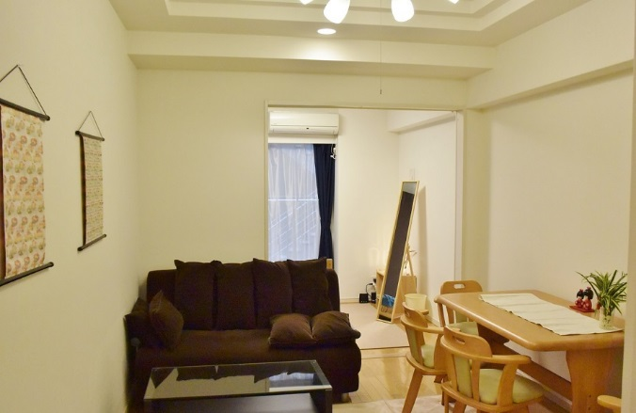

**High Speed Internet**

Wired & Wireless LAN both Available